Project Design Phase Problem – Solution Fit Template

Date | 2 NOVEMBER 2025
Team ID | NM2025TMID01022
Project Name | Streamlining Ticket Assignment for Effective Support System
Maximum Marks | 2 Marks

Problem – Solution Fit Template:
The project “Streamlining Ticket Assignment for Effective Support System” addresses a critical challenge in IT and customer support workflows — inefficient ticket distribution and delayed response times. In many support systems, tickets are manually assigned or unevenly distributed among agents, leading to workload imbalance, longer resolution periods, and reduced customer satisfaction
Purpose:
->Solve complex operational inefficiencies by automating ticket distribution and ensuring the right issues reach the right agents.
->Increase productivity and customer satisfaction through reduced response and resolution time

Template: 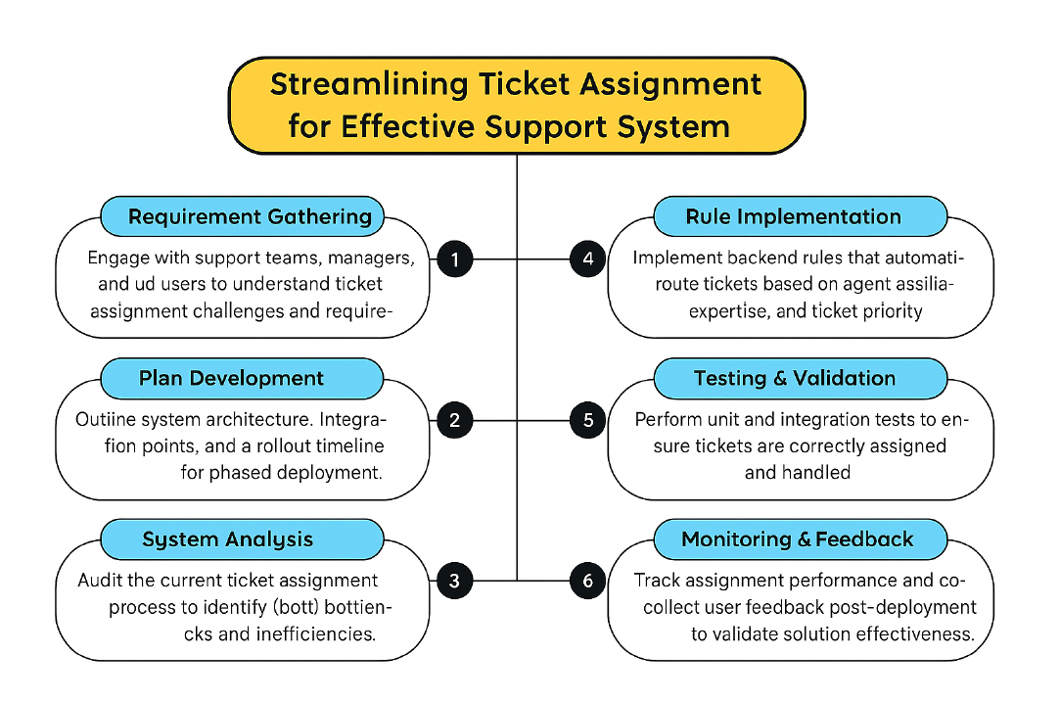
References:
- https://www.ideahackers.network/problem-solution-fit-canvas/
- https://medium.com/@epicantus/problem-solution-fit-canvas-aa3dd59cb4fe
The project “Streamlining Ticket Assignment for Effective Support System” addresses a major inefficiency in helpdesk and IT support management, where manual or unbalanced ticket distribution often leads to delayed responses and reduced service quality. By automating the ticket assignment process based on agent expertise, workload, and ticket priority, this solution ensures fair distribution and faster resolution of issues. It enhances operational efficiency, accountability, and transparency within the support environment. Through the successful implementation of rule-based automation, real-time monitoring, and performance analytics, this project lays the foundation for a smarter, data-driven support system that improves customer satisfaction and optimizes team productivity across enterprise platforms.

